OpenHTF - Scanner Parameter Settings Report LS2208
Summary Information | 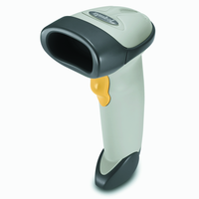 | 

Report Type:  Configuration name in Utility:  Last Modified:  Windows Filename:  Plug-in Name:  Notes: | Only parameters changed from defaults shown  OpenHTF  08-Oct-21  Config File_LS2208_OpenHTF_2021.07.28.scncfg  LS2208-COMMON MODELS v2.0-010

General Parameter Settings

Beeper

Beeper Volume | Low^

